Experiment 8: Sinusoidal State Response of a 2nd Order Circuit

By:

Shawn Keene, Jason Gilman

Supervisor: Saad Muaddi

Data collected on: 11/20/2019

Due: 12/04/2019

ECEN 214-508, Electrical Circuit Theory

Fall 2019

Prof. Scott Miller

**Procedure:**

Task 1 of the experiment involved students building the Sallen-Key circuit they designed in their prelab. Once the circuit was built, an AC voltage source was connected to the input. After the voltage source was connected, an oscilloscope was connected to both the input and output of the Sallen-Key. The measurements taken were the amplitude of the input voltage, amplitude of the output voltage, and the phase difference between the amplitude of the input and output voltages. These measurements were then taken again from 10Hz, 18Hz, 32Hz, 56Hz, 100Hz, 178Hz, 316Hz, 562Hz, 1,000Hz, 1,778Hz, 3,162Hz, 5,623Hz, and 10kHz frequencies. Once all frequencies were measured, the frequency of the sine wave was adjusted until the ratio of the output voltages vs the input voltage was 0.707. This frequency was then recorded

After the steps for task 1 were complete, students moved on to task 2. THis task involved following the same steps for the first task. However, the resistors and capacitors had their positions switched in the Sallen-Key.

**Data:**

Low Pass Circuit

|  |  |  |  |  |  |  |  |
| --- | --- | --- | --- | --- | --- | --- | --- |
| Frequency (Hz) | Phase Difference | Amplitude Input (V) | Amplitude Output (V) | P2P Input (V) | P2P Output (V) | Magnitude Response | Phase Response |
| 1.00E+01 | 1.19E-01 | 2.002 | 2.0052 | 4.005 | 4.0111 | 1.000666685 | -1.152845808 |
| 1.80E+01 | 1.26E-01 | 2.002 | 2.0079 | 4.0047 | 4.0165 | 1.002162155 | -2.078539323 |
| 3.20E+01 | 1.82E-01 | 2.0018 | 2.0164 | 4.0047 | 4.0336 | 1.006854174 | -3.714268177 |
| 5.60E+01 | 1.64E-01 | 2.002 | 2.0438 | 4.0047 | 4.0883 | 1.021181725 | -6.602450156 |
| 1.00E+02 | 2.64E-01 | 2.0022 | 2.1346 | 4.006 | 4.2716 | 1.069494725 | -12.41756153 |
| 1.78E+02 | 4.50E-01 | 2.002 | 2.438 | 4.0054 | 4.8781 | 1.237074049 | -26.27862559 |
| 3.16E+02 | 7.06E-01 | 2.0017 | 2.786 | 2.0017 | 5.5719 | 1.540663949 | -78.20062489 |
| 5.00E+02 | 2.27E+00 | 2 | 1.39 | 4 | 2.78 | 0.6478470213 | 40.63869614 |
| 5.62E+02 | 2.50E+00 | 2.0008 | 1.0476 | 2.0008 | 2.0965 | 0.6478470213 | 32.95213399 |
| 1.00E+03 | 2.67E+00 | 2.0005 | 0.27975 | 4.0043 | 0.56393 | 0.4813748542 | 14.66114958 |
| 1.78E+03 | 3.02E+00 | 2 | 0.08333 | 4.0037 | 0.18877 | 0.1258826141 | 7.695354024 |
| 3.16E+03 | 3.08E+00 | 2 | 0.02466 | 4.0027 | 0.29795 | 0.03745742148 | 4.235904954 |
| 5.62E+03 | 3.29E+00 | 1.9995 | 0.16275 | 4.0027 | 0.47141 | 0.0116181283 | 2.366134171 |
| 1.00E+04 | 3.45E+00 | 1.9996 | 0.34608 | 4.003 | 0.72855 | 0.003651702215 | 1.327677649 |

The cutoff frequency for the low pass circuit occurred at 500 Hz. The theoretical and measured data has the same values.

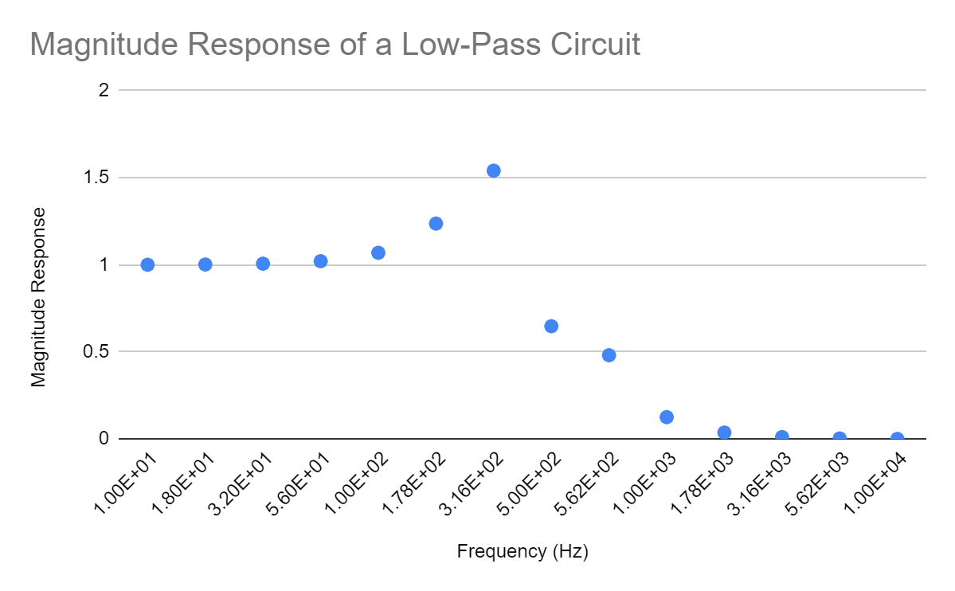

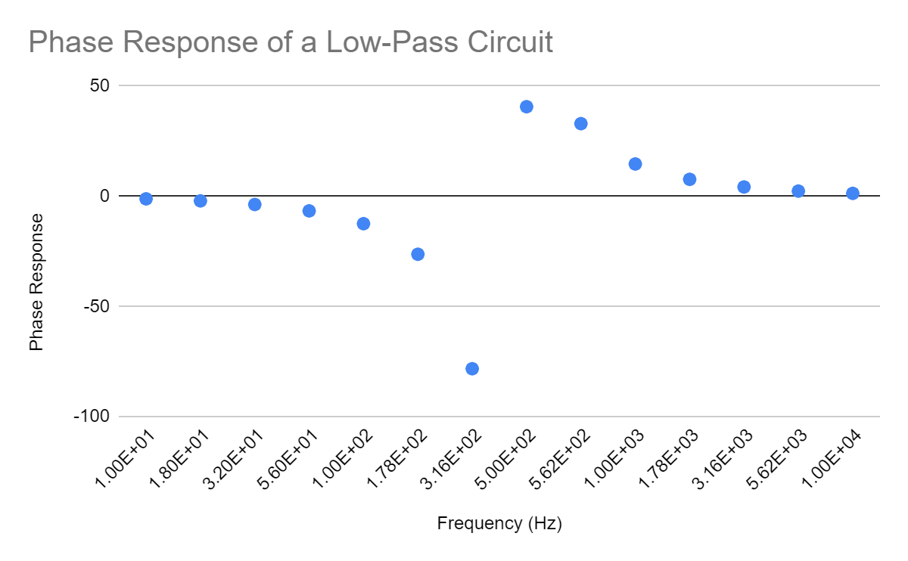

High Pass Circuit

|  |  |  |  |  |  |  |  |
| --- | --- | --- | --- | --- | --- | --- | --- |
| Frequency (Hz) | Phase Difference | Amplitude Input (V) | Amplitude Output (V) | P2P Input (V) | P2P Output (V) | Magnitude Response | Phase Response |
| 1.00E+01 | 3.15E+00 | 1.0004 | 8.50E-04 | 2.0022 | 4.08E-03 | 0.0008013012795 | 4.74566208 |
| 1.80E+01 | 3.29E+00 | 1.0002 | 2.55E-03 | 2.0018 | 9.86E-03 | 0.002441913316 | 8.516870045 |
| 3.20E+01 | 3.30E+00 | 1.0006 | 8.33E-03 | 2.0022 | 0.02347 | 0.006974438382 | 15.00399056 |
| 5.60E+01 | 3.49E+00 | 1.0006 | 0.02449 | 2.0022 | 0.05884 | 0.01822584323 | 25.58501374 |
| 1.00E+02 | 3.80E+00 | 1.0004 | 0.07075 | 2.0029 | 0.16224 | 0.04512010813 | 42.52043103 |
| 1.78E+02 | 4.16E+00 | 1.0001 | 0.17704 | 2.0025 | 0.38842 | 0.09902252977 | 64.71727118 |
| 3.16E+02 | 4.65E+00 | 1.0001 | 0.36598 | 2.0032 | 0.78467 | 0.1895746543 | 88.99451298 |
| 5.62E+02 | 5.07E+00 | 1.0002 | 0.60985 | 2.0025 | 1.2884 | 0.2881503788 | -71.48869155 |
| 7.20E+02 | 5.25E+00 | 1 | 0.707 | 2 | 1.414 | 0.3160853069 | -66.59526651 |
| 1.00E+03 | 5.49E+00 | 1.0001 | 0.81375 | 2.0029 | 1.7098 | 0.4608151872 | -44.11594776 |
| 1.78E+03 | 5.93E+00 | 0.99956 | 0.92854 | 2.0022 | 1.9299 | 0.5975493369 | -26.79263796 |
| 3.16E+03 | 5.98E+00 | 0.99922 | 0.99776 | 2.0015 | 1.9993 | 0.7074549424 | -15.50676477 |
| 5.62E+03 | 6.09E+00 | 0.99939 | 1.0144 | 2.0018 | 2.0377 | 0.7852577813 | -8.805123705 |
| 1.00E+04 | 6.33E+00 | 0.99922 | 1.0197 | 2.0018 | 2.0493 | 0.8356701855 | -4.966682874 |

The cutoff frequency for the high pass circuit occurred at 720 Hz. The theoretical and measured data has the same values.

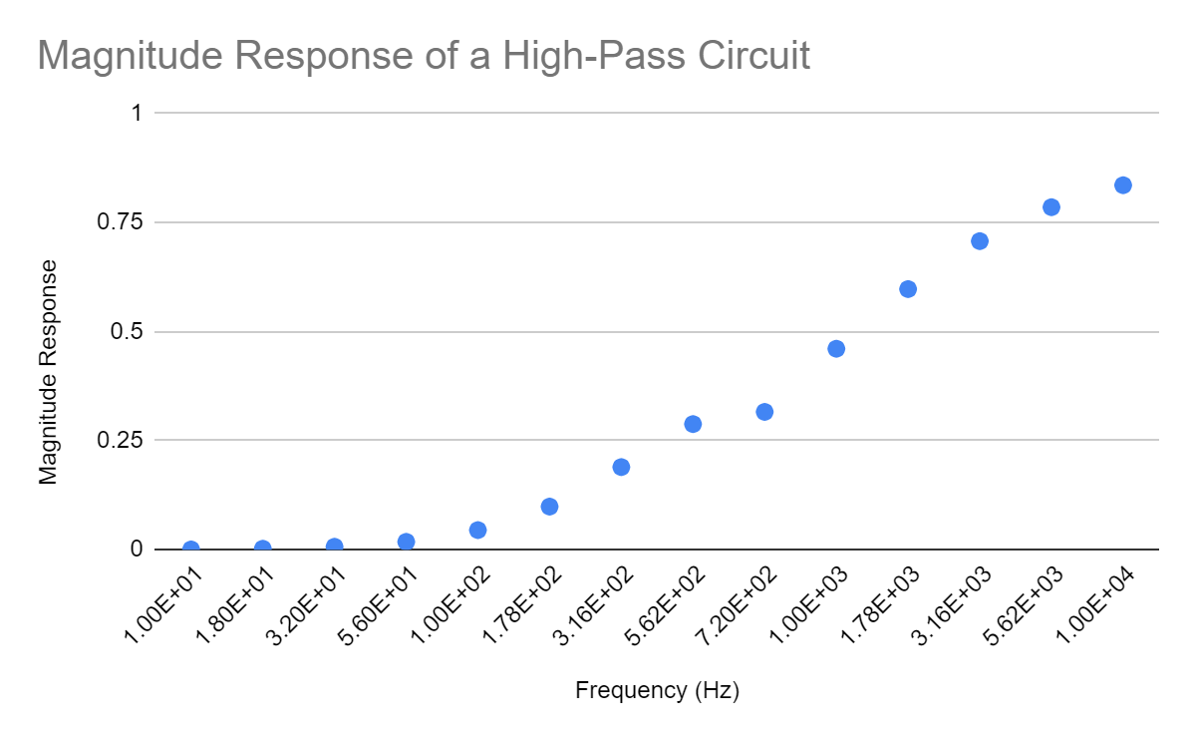

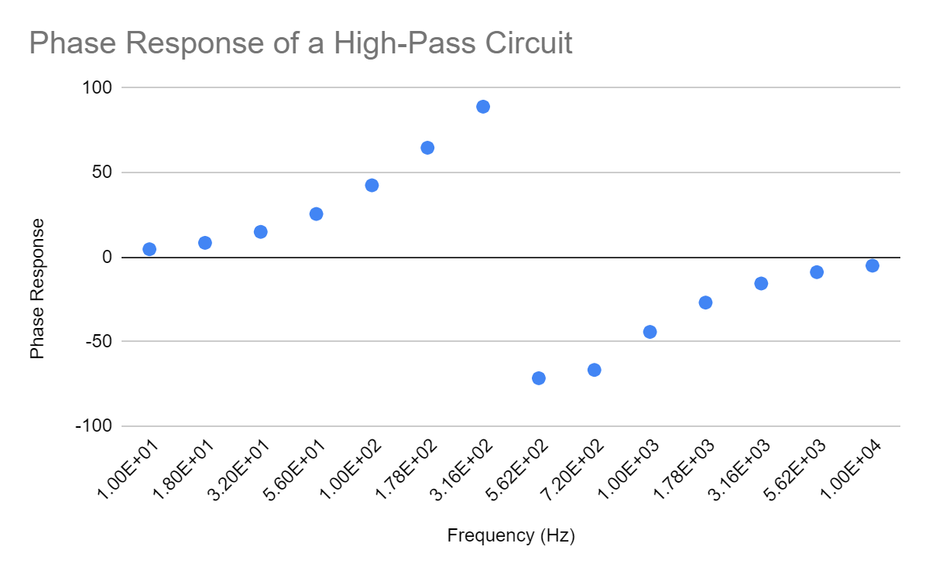

**Discussion:**

For the low pass circuit the pass and stop band was around 500 Hz. This is because the magnitude response is below .707, the amplitude steeply drops from 2.79 V to 1.4 V and continued to drop at higher frequencies until it hit 0.35 V.

For the high pass circuit the pass and stop band was around 316 Hz. This is because the magnitude response is .707.

In order to change the cutoff frequency or the pass and stop bands, due to the transfer function, one has to change the R and C values of the circuit.

At some points in the tasks, the output voltage was greater than the input. This does not violate the conservation of energy because of the way op amps work. The op amp is connected to an external voltage source, so it is going to amplify the input voltage.

Changes that could make our results better would be to use smaller increments in between frequencies. This would give a much less choppy graph.